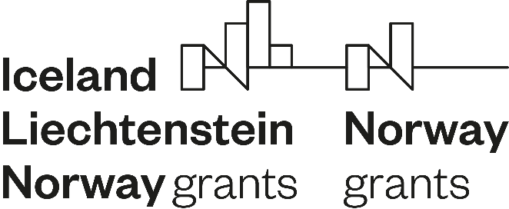

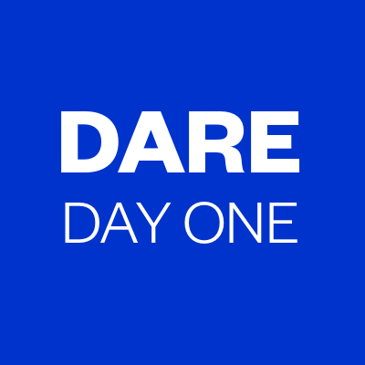

SEPTEMBER 2020
PRESS RELEASE
PROJECT “DARE-DAY ONE ALLIANCE FOR EMPLOYMENT”- Strengthening transnational cooperation to meet the European challenges in the field of youth employment.
The Funding Mechanism Office (FMO) for grants from the EEA and Norway has awarded the financing of the project titled "DARE-Day One Alliance for Employment" which was submitted by the organization SEAL CYPRUS.
The project started in April 2019 and runs for three years. The approved grant amounts was 1,178,000 euros. The grant support is 85%. The partners’ contribution is 15%.
"DARE-Day One Alliance for Employment" is intended to contribute to the specific objective of the fund "Strengthening transnational cooperation to meet the European challenges in the field of youth employment". The target groups of the project are:
(A) Young people without employment, education or training (NEET) in Cyprus, Greece, Italy and Portugal. The target group includes the long-term unemployed, discouraged people who are no longer looking for work, inactive women caring for children or disabled adults, ethnic minorities such as Roma, asylum seekers, the low-skilled, people with mental health problems and people with disabilities.
(B) Employees who wish to support the Open Badges system for validating non-formal learning.
SEAL CYPRUS leads a consortium of ten organizations from eight countries. Five partners will carry out measures to help the unemployed in four countries:
SEAL CYPRUS - Cyprus Organization for Sustainable Education and Active Learning (Leading Partner), Association of Crafts and SMEs / Confartigianato Imprese Salerno (Italy), STRATIS Consulting (Greece), PAR- Respostas Sociais (Portugal).
Cyprus, Greece, Italy and Portugal face challenges in career planning, entrepreneurship training and validation of learning. The experience of other European countries has shown that initiatives to improve the above areas increase employment opportunities for young people.
The proposed interventions include job labs and entrepreneurship labs for 1,400 young people who are not in education, employment or training. A system of validation of non-formal learning with open badges is put in place for the benefit of the participants.
Five partners will transfer expertise in career planning, entrepreneurship training and validation of non-formal learning from three countries:
Lithuanian Association for Non-Formal Education (Lithuania), Youth Careers and Counselling Center (Lithuania), Chamber of Commerce and Industry Lodz (Poland), IFTE Initiative for Teaching Entrepreneurship (Austria), Austrian Federal Chamber of Commerce (Austria).
More on the project: https://sealcyprus.org/dare/
To follow the developments of the project on Facebook, please follow the link https://www.facebook.com/DareDay1Youth

THE EEA AND NORWAY GRANTS
Working together for a green, competitive and inclusive Europe
The EEA and Norway Grants have their basis in the EEA Agreement. Under the Agreement, Iceland, Liechtenstein and Norway are part of the EU’s internal market. The EEA Agreement sets out the common goal of working together to reduce social and economic disparities in Europe and strengthening cooperation between donor and beneficiary countries. Iceland, Liechtenstein and Norway have allocated EUR 2.8 billion to 15 EU countries for this purpose. Norway provides just under 98 % of this amount.
The EEA and Norway Grants are important tools in the Norwegian Government’s active European policy, which seeks to promote a green, competitive and inclusive Europe.
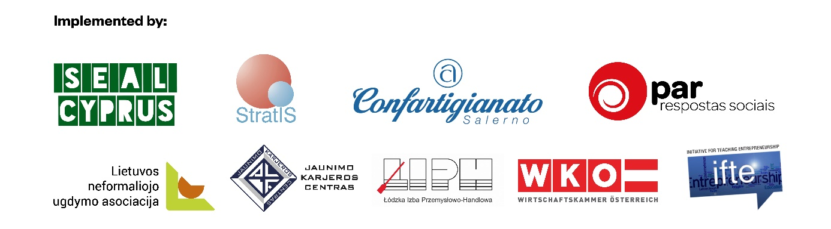

“The DARE project is funded by Iceland, Liechtenstein and Norway through the EEA and Norway Grants Fund for Youth Employment”.

